ITA0305- Mobile Computing
LAB EXPERIMENT
Name: G.Ganesh
Reg NO:192373008

7) Develop a dashboard prototype in Figma displaying performance criteria for a
cellular system.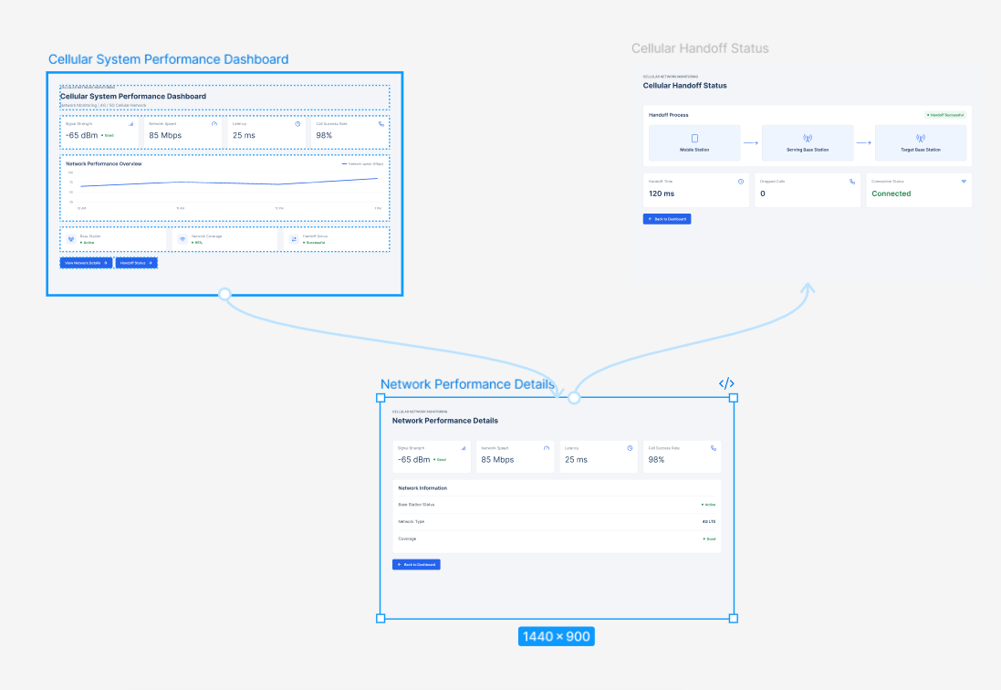
https://www.figma.com/design/K1mhqr2ZzdHOIoe43JpatF/program07?node-id=0-1&p=f&t=7V8NXOJ1ecOAWj2u-0

